Chapter 5

Tools and Datasets
3.1 Dataset Description
The effectiveness of any deep learning-based image classification system is fundamentally dependent on the quality, diversity, and representativeness of the dataset used during model development. A well-constructed dataset enables the neural network to learn robust feature representations, improves generalization capability, and reduces the likelihood of overfitting. Since the objective of this research is to develop an Edge AI system capable of accurately classifying indigenous Bangladeshi mango varieties under practical deployment conditions, it is essential that the training dataset adequately represents the visual diversity encountered in real agricultural environments.
Table 3.1 Distribution of Mango Varieties in the Mangifera2012 Dataset

Class | Mango Variety | Number of Images
1 | Amrapali | 252
2 | Bari-4 | 235
3 | Bari-7 | 176
4 | Fazlee | 156
5 | Harivanga | 202
6 | Kanchon Langra | 210
7 | Katimon | 163
8 | Langra | 202
9 | Mollika | 221
10 | Nilambori | 195
Total | 10 Classes | 2,012 Images

The dataset exhibits a relatively balanced class distribution, with each variety containing between 156 and 252 images. Although slight variations exist among individual classes, the distribution is sufficiently uniform to minimize significant class imbalance during model training. Maintaining a balanced dataset is important because highly imbalanced class distributions often bias deep learning models toward majority classes, resulting in poor classification performance for minority categories.

3.1.1 Dataset Composition
The quality and composition of a dataset play a crucial role in determining the performance and generalization capability of deep learning models. In image classification tasks, an appropriately designed dataset should provide sufficient visual diversity while maintaining representative samples for each target category. A dataset containing balanced class distributions and diverse visual characteristics enables convolutional neural networks to learn discriminative feature representations more effectively, thereby improving their robustness when presented with previously unseen images [1]. Consequently, careful examination of the dataset composition is essential before discussing the model training process.
The dataset contains images of the following ten mango varieties:
- Amrapali
- Bari-4
- Bari-7
- Fazlee
- Harivanga
- Kanchon Langra
- Katimon
- Langra
- Mollika
- Nilambori

Table 3.2 Class-wise Distribution of the Mangifera2012 Dataset
Class ID | Mango Variety | Number of Images | Percentage (%)
1 | Amrapali | 252 | 12.53
2 | Bari-4 | 235 | 11.68
3 | Bari-7 | 176 | 8.75
4 | Fazlee | 156 | 7.75
5 | Harivanga | 202 | 10.04
6 | Kanchon Langra | 210 | 10.44
7 | Katimon | 163 | 8.10
8 | Langra | 202 | 10.04
9 | Mollika | 221 | 10.98
10 | Nilambori | 195 | 9.69
Total | 10 Classes | 2,012 | 100

As shown in Table 3.2, the dataset demonstrates a relatively balanced distribution. The largest class, Amrapali, contains 252 images, whereas Fazlee, the smallest class, contains 156 images.
Another important characteristic of the dataset is that every image contains a single mango instance, allowing the research to focus exclusively on image classification rather than object detection or instance segmentation. This simplifies the learning objective by assigning exactly one ground-truth label to each input image, enabling the evaluated CNN models to learn direct mappings between image features and mango varieties. Consequently, the task formulation can be expressed mathematically as
$$[f\left(I\right)→y]$$
where
- I denotes the input mango image,
- f(.) represents the deep convolutional neural network,
- $(y ∈\{1,2,…,10\})$ denotes the predicted mango variety.
This formulation defines a standard supervised multi-class classification problem in which the network estimates the posterior probability of each class using the Softmax activation function, and the class with the highest probability is selected as the final prediction.

3.1.2 Data Preprocessing and Augmentation
The quality of input data plays a fundamental role in the performance and generalization capability of deep learning models. Raw images collected from real-world environments often exhibit variations in resolution, orientation, illumination, scale, and viewpoint, which may negatively influence the learning process if not handled appropriately.
Image Resizing
The original images in the Mangifera2012 dataset have a native resolution of 3024 × 4032 pixels, which is considerably larger than the input size required by lightweight convolutional neural networks. Therefore, every input image was resized to 224 × 224 pixels, which corresponds to the standard input dimension required by MobileNetV2, MobileNetV3-Small, EfficientNetV2B0, DenseNet121, and NASNetMobile. During resizing, the RGB color channels were preserved, producing input tensors of dimension
$$[ 224 ×224 ×3 ]$$
This resizing operation provides an effective balance between computational efficiency and feature preservation.
Architecture-Specific Input Preprocessing
An important aspect of this research is the implementation of architecture-specific preprocessing, ensuring that each convolutional neural network receives input data in the format expected by its original ImageNet pre-training configuration.
During implementation, TensorFlow's built-in preprocessing functions were utilized as follows:
- MobileNetV2 → mobilenet_v2.preprocess_input()
- MobileNetV3-Small → mobilenet_v3.preprocess_input()
- EfficientNetV2B0 → efficientnet_v2.preprocess_input()
- DenseNet121 → densenet.preprocess_input()
- NASNetMobile → nasnet.preprocess_input()

Data Augmentation
Although the Mangifera2012 dataset provides a balanced representation of indigenous mango varieties, its size remains relatively modest compared with large-scale computer vision datasets. Training deep neural networks directly on limited data increases the risk of overfitting, where the model memorizes training samples instead of learning generalized visual representations.
The augmentation operations used in this research are summarized in Table 3.3.
Table 3.3 Data Augmentation Configuration
Augmentation Technique | Parameter | Purpose
Rotation | ±30° | Simulates different camera orientations
Width Shift | 20% | Handles horizontal displacement
Height Shift | 20% | Handles vertical displacement
Shear Transformation | 20% | Introduces geometric variation
Zoom | 20% | Simulates different camera distances
Horizontal Flip | Enabled | Handles mirrored fruit orientation
Fill Mode | Nearest | Preserves image continuity after transformation

Training and Validation Data Generation
Following preprocessing and augmentation, TensorFlow's ImageDataGenerator was used to automatically generate batches of images during training. The dataset was divided into:
- 80% Training Set
- 20% Validation Set
using a fixed random seed to ensure reproducibility. The training generator applied both preprocessing and augmentation, whereas the validation generator performed only architecture-specific preprocessing without augmentation. This strategy ensures that validation performance accurately reflects the model's generalization capability on unseen data.

Workflow of the Preprocessing Pipeline
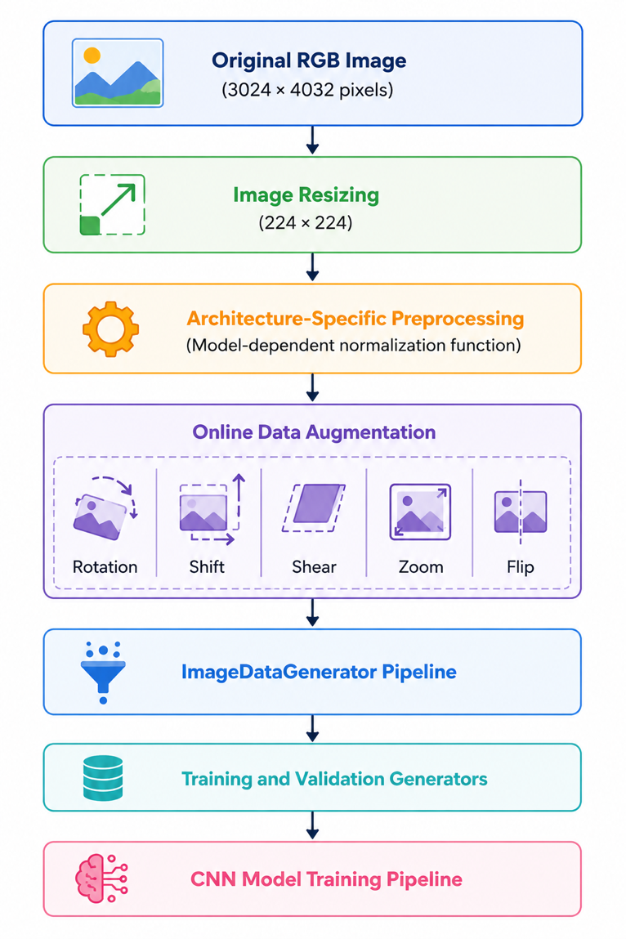
The complete preprocessing pipeline implemented in this research is illustrated conceptually in Figure 3.3.

Figure 3.3: Overview of the preprocessing and augmentation pipeline employed before CNN training.

